OFFER REQUEST  Territorial Analysis - mapping of the cultural/environmental/natural assets to identify specific regional pilot area - Zenica-Doboj Canton  Reference: 19-24-1247-10/20 | 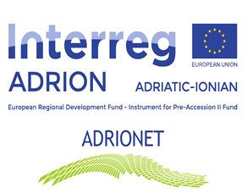

Department for Development and International Projects of Zenica-Doboj Canton intends to award a service contract for Territorial Analysis - mapping of the cultural/ environmental/ natural assets to identify specific regional pilot area in Zenica-Doboj Canton with financial assistance from the EU INTERREG ADRIATIC-IONIAN 2014-2020 (ADRION) PROGRAMME (IPA II instrument).

The Offer request and supporting documents:

T1.1 ADRIONET Offer Request.docx
Adrionet report_Table of contents.docx
Slides Adrionet project.pptx

The deadline for submission of applications is April 30, 2020 at 16:00

