OFFER REQUEST  External Expertise for Realisation of Activities Under the ADRIONET Work Package 3 (T2)  in Zenica-Doboj Canton  Reference: 19-24-729-41/21 | 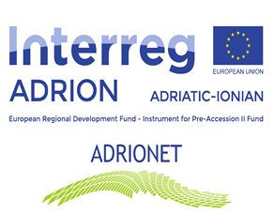

Department for Development and International Projects of Zenica-Doboj Canton intends to award a service contract for External Expertise for Realisation of Activities Under the ADRIONET Work Package 3 (T2 – Implementation of Pilot Demonstration Actions) with financial assistance from the EU INTERREG ADRIATIC-IONIAN 2014-2020 (ADRION) PROGRAMME (IPA II instrument).

Invitation to tender and other relevant documents:

ADRIONET External Services WP3 T2.zip

The deadline for submission of applications is October 12, 2021, at 16:00

