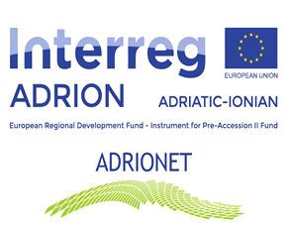
CANCELLATION OF A TENDER PROCEDURE

Contract Notice Title: EXTERNAL EXPERTIZE FOR REALIZATION OF ACTIVITIES UNDER THE ADRIONET WORK PACKAGE 4 (T3), ZENICA
Publication Reference Number: 19-24-323-1/22
Instructions to tenderers, Section 15: Cancellation of the tender procedure

The tender procedure is cancelled: yes
The contract/lot is not awarded due to the: discontinuation of procedure before the deadline for submitting tenders;

as of: January 31st, 2022 under Notice reference: (2022) 19-24-323-1/22;

